**EXPERIMENT 1 Date: 17th January 2023**

**TITLE:** **DDL (Data Definition Language) commands**

**Objective:** To understand the concept of designing issue related to the database with creating, populating the tables.

1. **CREATE THE TABLES DESCRIBED BELOW:**

**Table name: CLIENT_MASTER**

|  |  |  |
| --- | --- | --- |
| **Column name** | **Data type** | **Size** |
| CLIENTNO | Varchar | 6 |
| NAME | Varchar | 20 |
| ADDRESS 1 | Varchar | 30 |
| ADDRESS 2 | Varchar | 30 |
| CITY | Varchar | 15 |
| PINCODE | Integer |  |
| STATE | Varchar | 15 |
| BALDUE | decimal | 10.2 |

**Query:**

CREATE TABLE CLIENT_MASTER (

CLIENTNO VARCHAR (6),

NAME VARCHAR (20),

ADDRESS1 VARCHAR (30),

ADDRESS2 VARCHAR (30),

CITY VARCHAR (15),

PINCODE INTEGER,

STATE VARCHAR (15),

BALDUE DECIMAL (10,2)

);

DESC CLIENT_MASTER;

**Output:**

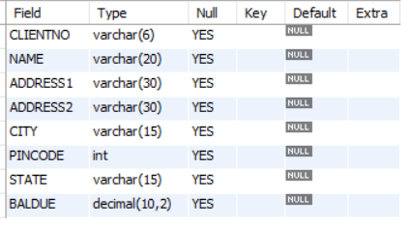

**Table name: PRODUCT_MASTER**

|  |  |  |
| --- | --- | --- |
| **Column name** | **Data type** | **Size** |
| PRODUCTNO | Varchar | 6 |
| DESCRIPTION | Varchar | 15 |
| PROFITPERCENT | Decimal | 4.2 |
| UNIT MEASURE | Varchar | 10 |
| QTYONHAND | Integer |  |
| REORDERL VL | Integer |  |
| SELLPRICE | Decimal | 8.2 |
| COSTPRICE | Decimal | 8.2 |

**Query:**

CREATE TABLE PRODUCT_MASTER(

PRODUCTNO VARCHAR (6),

DESCRIPTION VARCHAR(15),

PROFIT_PERCENT DECIMAL (4,2),

UNIT_MEASURE VARCHAR (10),

QTY_ON_HAND INTEGER,

REORDERL_VL INTEGER,

SELLPRICE DECIMAL(8,2),

COST_PRICE DECIMAL(8,2)

);

DESC PRODUCT_MASTER;

**Output:**

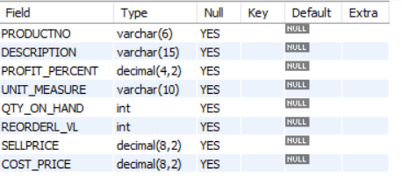

**Table name: SALESMAN_MASTER**

|  |  |  |
| --- | --- | --- |
| **Column name** | **Data type** | **Size** |
| SALESMANNO | Varchar | 6 |
| SALESMANNAME | Varchar | 20 |
| ADDRESS 1 | Varchar | 30 |
| ADDRESS 2 | Varchar | 30 |
| CITY | Varchar | 20 |
| PINCODE | Integer |  |
| STATE | Varchar | 20 |
| SALAMT | Real |  |
| TGTTOGET | Decimal |  |
| YTDSALES | Double | 6.2 |
| REMARKS | Varchar | 60 |

**Query:**

CREATE TABLE SALESMAN_MASTER(

SALESMANNO VARCHAR (6),

SALESMANNAME VARCHAR(20),

ADDRESS1 VARCHAR(30),

ADDRESS2 VARCHAR(30),

CITY VARCHAR (20),

PINCODE INTEGER,

STATE VARCHAR (20),

SALAMT REAL,

TGTTOGET DECIMAL,

YTDSALES DOUBLE(6,2),

REMARKS VARCHAR (60)

);

DESC SALESMAN_MASTER;

**Output:**

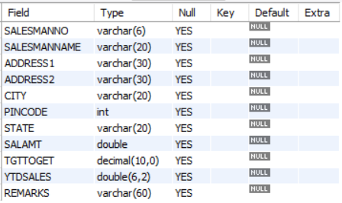

1. **INSERT DATA INTO THE RESPECTIVE TABLES:**
   1. **Data for CLIENT_MASTER table:**

|  |  |  |  |  |  |
| --- | --- | --- | --- | --- | --- |
| **Client no** | **Name** | **City** | **Pincode** | **State** | **BalDue** |
| C00001 | Ivan bayross | Mumbai | 400054 | Maharashtra | 15000 |
| C00002 | Mamta muzumdar | Madras | 780001 | Tamil nadu | 0 |
| C00003 | Chhaya bankar | Mumbai | 400057 | Maharashtra | 5000 |
| C00004 | Ashwini joshi | Bangalore | 560001 | Karnataka | 0 |
| C00005 | Hansel colaco | Mumbai | 400060 | Maharashtra | 2000 |
| C00006 | Deepak sharma | Mangalore | 560050 | Karnataka | 0 |

**Query:**

INSERT INTO CLIENT_MASTER VALUES("C00001", "Ivan bayross", NULL, '', "Mumbai", 400054, "Maharashtra", 15000);

INSERT INTO CLIENT_MASTER(CLIENTNO, NAME, CITY, PINCODE, STATE, BALDUE) VALUES("C00002", "Mamta muzumdar", "Madras", 780001, "Tamil nadu", 0);

INSERT INTO CLIENT_MASTER(CLIENTNO, NAME, CITY, PINCODE, STATE, BALDUE) VALUES('C00003', 'Chhaya bankar', 'Mumbai', 400057, 'Maharashtra', 5000);

INSERT INTO CLIENT_MASTER(CLIENTNO, NAME, CITY, PINCODE, STATE, BALDUE) VALUES('C00004', 'Ashwini joshi', 'Bangalore', 560001, 'Karnataka', 0);

INSERT INTO CLIENT_MASTER(CLIENTNO, NAME, CITY, PINCODE, STATE, BALDUE) VALUES('C00005', 'Hansel colaco', 'Mumbai', 400060, 'Maharashtra', 2000);

INSERT INTO CLIENT_MASTER(CLIENTNO, NAME, CITY, PINCODE, STATE, BALDUE) VALUES('C00006', 'Deepak sharma', 'Mangalore', 560050, 'Karnataka', 0);

SELECT * FROM CLIENT_MASTER;

**Output:**

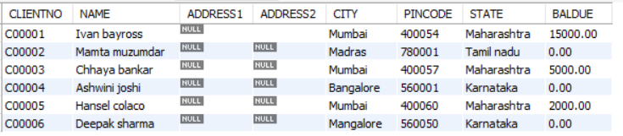

* 1. **Data for PRODUCT_MASTER table:**

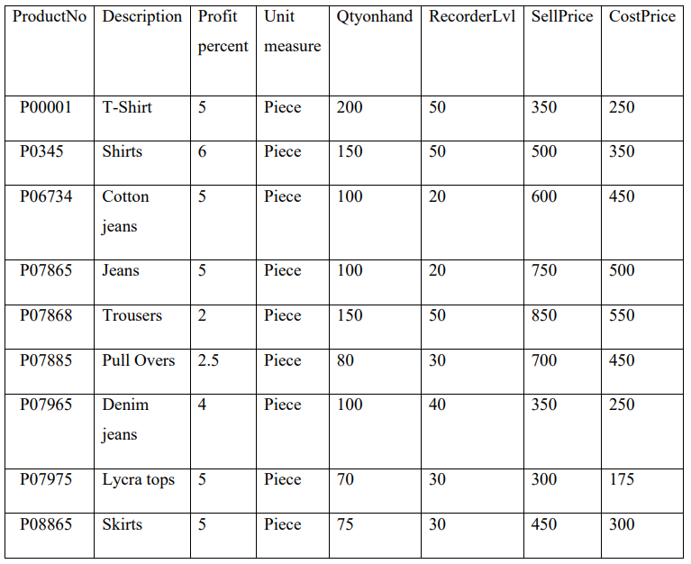

**Query:**

INSERT INTO PRODUCT_MASTER VALUES('P00001', 'T-Shirt', 5, 'Piece', 200, 50, 350, 250);

INSERT INTO PRODUCT_MASTER VALUES('P0345', 'Shirts', 6, 'Piece', 150, 50, 500, 350);

INSERT INTO PRODUCT_MASTER VALUES('P06734', 'Cotton jeans', 5, 'Piece', 100, 20, 600, 450);

INSERT INTO PRODUCT_MASTER VALUES('P07865', 'Jeans', 5, 'Piece', 100, 20, 750, 500);

INSERT INTO PRODUCT_MASTER VALUES('P07868', 'Trousers', 2, 'Piece', 150, 50, 850, 550);

INSERT INTO PRODUCT_MASTER VALUES('P07885', 'Pull Overs', 2.5, 'Piece', 80, 30, 700, 450);

INSERT INTO PRODUCT_MASTER VALUES('P07965', 'Denim jeans', 4, 'Piece', 100, 40, 350, 250);

INSERT INTO PRODUCT_MASTER VALUES('P07975', 'Lycra tops', 5, 'Piece', 70, 30, 300, 175);

INSERT INTO PRODUCT_MASTER VALUES('P08865', 'Skirts', 5, 'Piece', 75, 30, 450, 300);

SELECT * FROM PRODUCT_MASTER;

**Output:**

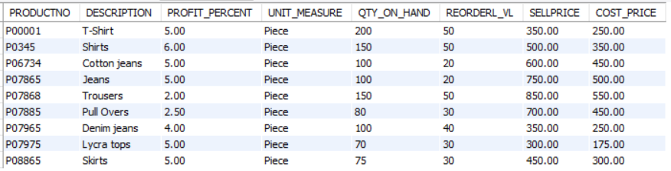

* 1. **Data for SALESMAN_MASTER table:**

|  |  |  |  |  |  |  |
| --- | --- | --- | --- | --- | --- | --- |
| **SalesmanNo** | **Name** | **Address1** | **Address2** | **City** | **Pincode** | **State** |
| S00001 | Aman | A/14 | Worli | Mumbai | 400002 | Maharashtra |
| S00002 | Omkar | 65 | Nariman | Mumbai | 400001 | Maharashtra |
| S00003 | Raj | P-7 | Bandra | Mumbai | 400032 | Maharashtra |
| S00004 | Ashish | A/5 | Juhu | Mumbai | 400044 | Maharashtra |

|  |  |  |  |  |
| --- | --- | --- | --- | --- |
| **SalesmanNo** | **SalAmt** | **TgtToGet** | **YtdSales** | **Remarks** |
| S00001 | 3000 | 100 | 50 | Good |
| S00002 | 3000 | 200 | 100 | Good |
| S00003 | 3000 | 200 | 100 | Good |
| S00004 | 3500 | 200 | 150 | Good |

**Query:**

INSERT INTO SALESMAN_MASTER VALUES('S00001', 'Aman', 'A/14', 'Worli', 'Mumbai', 400002, 'Maharashtra', 3000, 100, 50, 'Good');

INSERT INTO SALESMAN_MASTER VALUES('S00002', 'OMKAR', '65', 'NARIMAN', 'Mumbai', 400002, 'Maharashtra',3000, 200, 100, 'Good');

INSERT INTO SALESMAN_MASTER VALUES('S00003', 'RAJ', 'P-7', 'BANDRA', 'Mumbai', 400032, 'Maharashtra',3000, 200, 100, 'Good');

INSERT INTO SALESMAN_MASTER VALUES('S00004', 'ASHISH', 'A/5', 'JUHU', 'Mumbai', 400044, 'Maharashtra',3000, 200, 150, 'Good');

SELECT * FROM SALESMAN_MASTER;

**Output:**

